Asymmetric Closed Curved Shapes
# Source: AI Source: Provided by: [Data Path: Persons Table -> ID Column: 1, Name_En Column: Motasem Essam] -> From: [ChatGPT] on [7/25/2026]
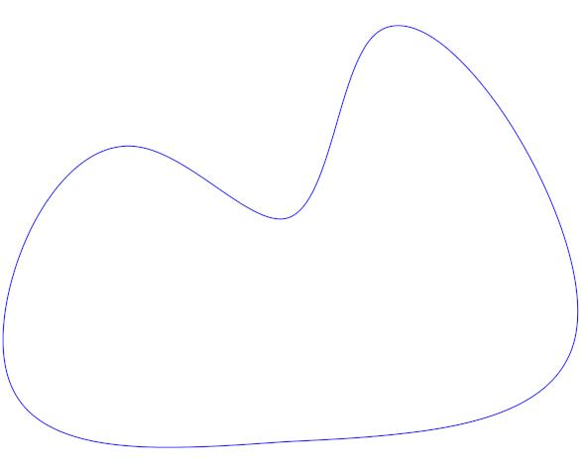
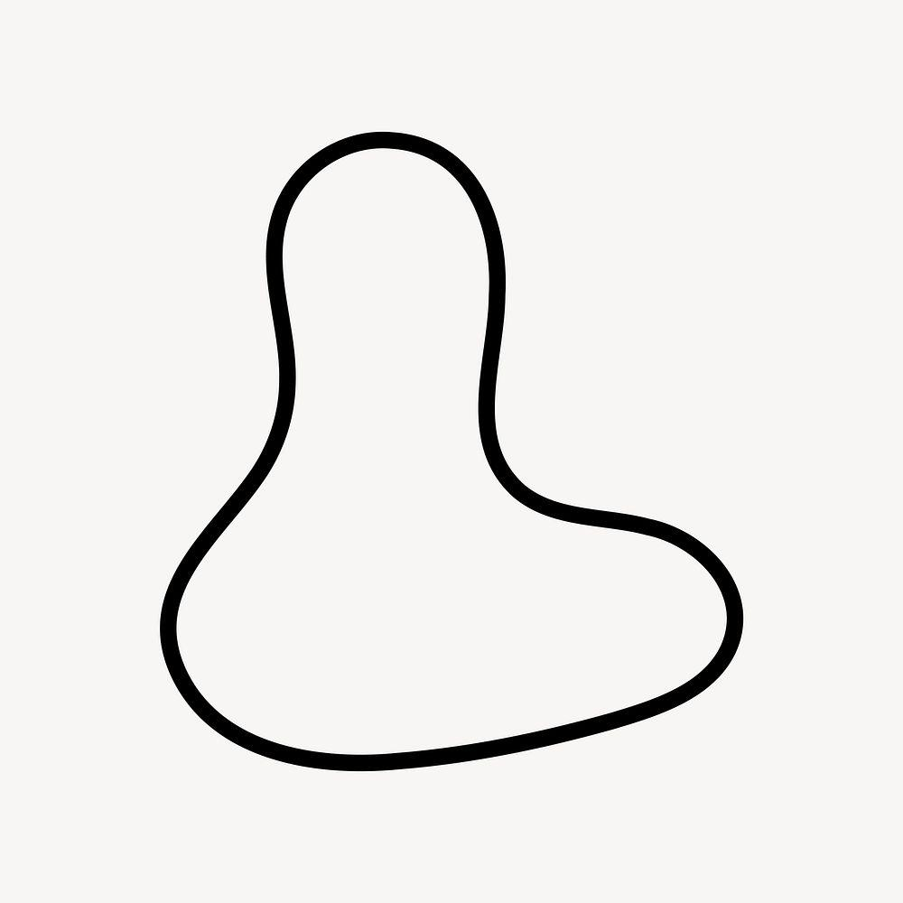
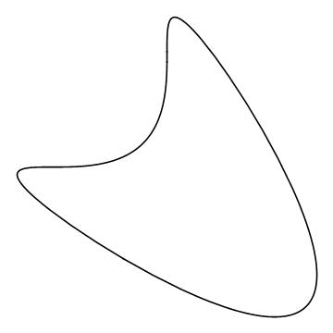
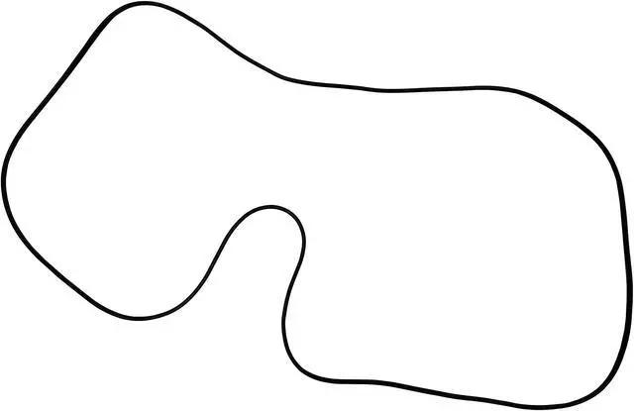
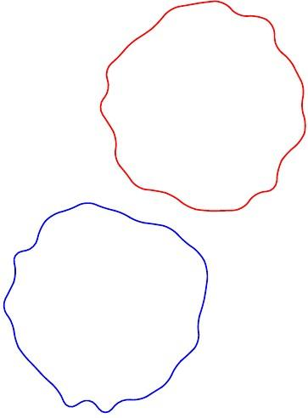

Definition
# Source: AI Source: Provided by: [Data Path: Persons Table -> ID Column: 1, Name_En Column: Motasem Essam] -> From: [ChatGPT] on [7/25/2026]
An Asymmetric Closed Curved Shape is a closed curved shape whose boundary does not have a regular axis of reflection symmetry or other regular symmetry pattern.
In simple terms:
It is a closed curved shape with an uneven or unbalanced curved boundary.
$$\boxed{\text{Asymmetric Closed Curved Shape}=\text{Closed}+\text{Curved}+\text{No Regular Symmetry}}$$
The curve still forms a complete closed boundary:
$$\boxed{P_{\text{start}}=P_{\text{end}}}$$
but its two sides, ends, or regions are not mirror images of one another.

Characteristics
# Source: AI Source: Provided by: [Data Path: Persons Table -> ID Column: 1, Name_En Column: Motasem Essam] -> From: [ChatGPT] on [7/25/2026]
An asymmetric closed curved shape typically:
- Is closed.
- Has a continuous curved boundary.
- Has no open endpoints.
- Encloses a bounded region.
- Has no straight sides in its pure curved form.
- Has no required line of reflection symmetry.
- May have different curvature on different portions.
- May have unequal widths or bulges.
- May be organic, oval-like, wavy, or freeform.
- May still have rotational symmetry in special cases, although most asymmetric shapes do not.

Types of Asymmetric Closed Curved Shapes

1. Asymmetric Oval Shapes
# Source: AI Source: Provided by: [Data Path: Persons Table -> ID Column: 1, Name_En Column: Motasem Essam] -> From: [ChatGPT] on [7/25/2026]
An asymmetric oval is an oval-like closed curve whose two sides or ends are not equivalent.
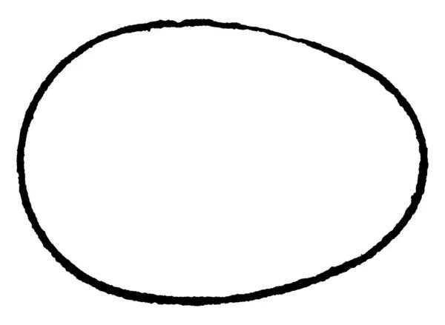
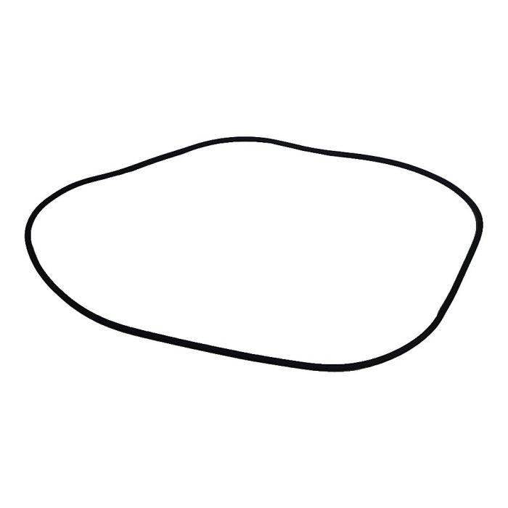
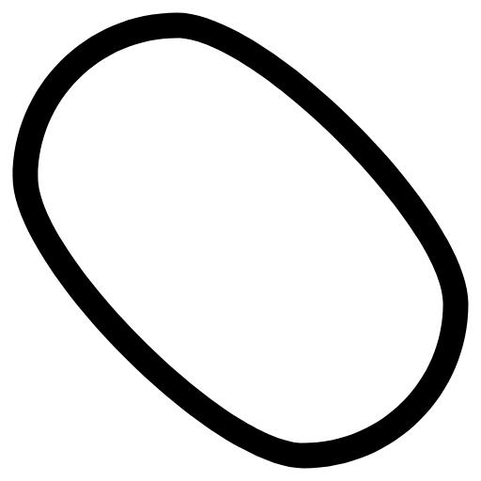
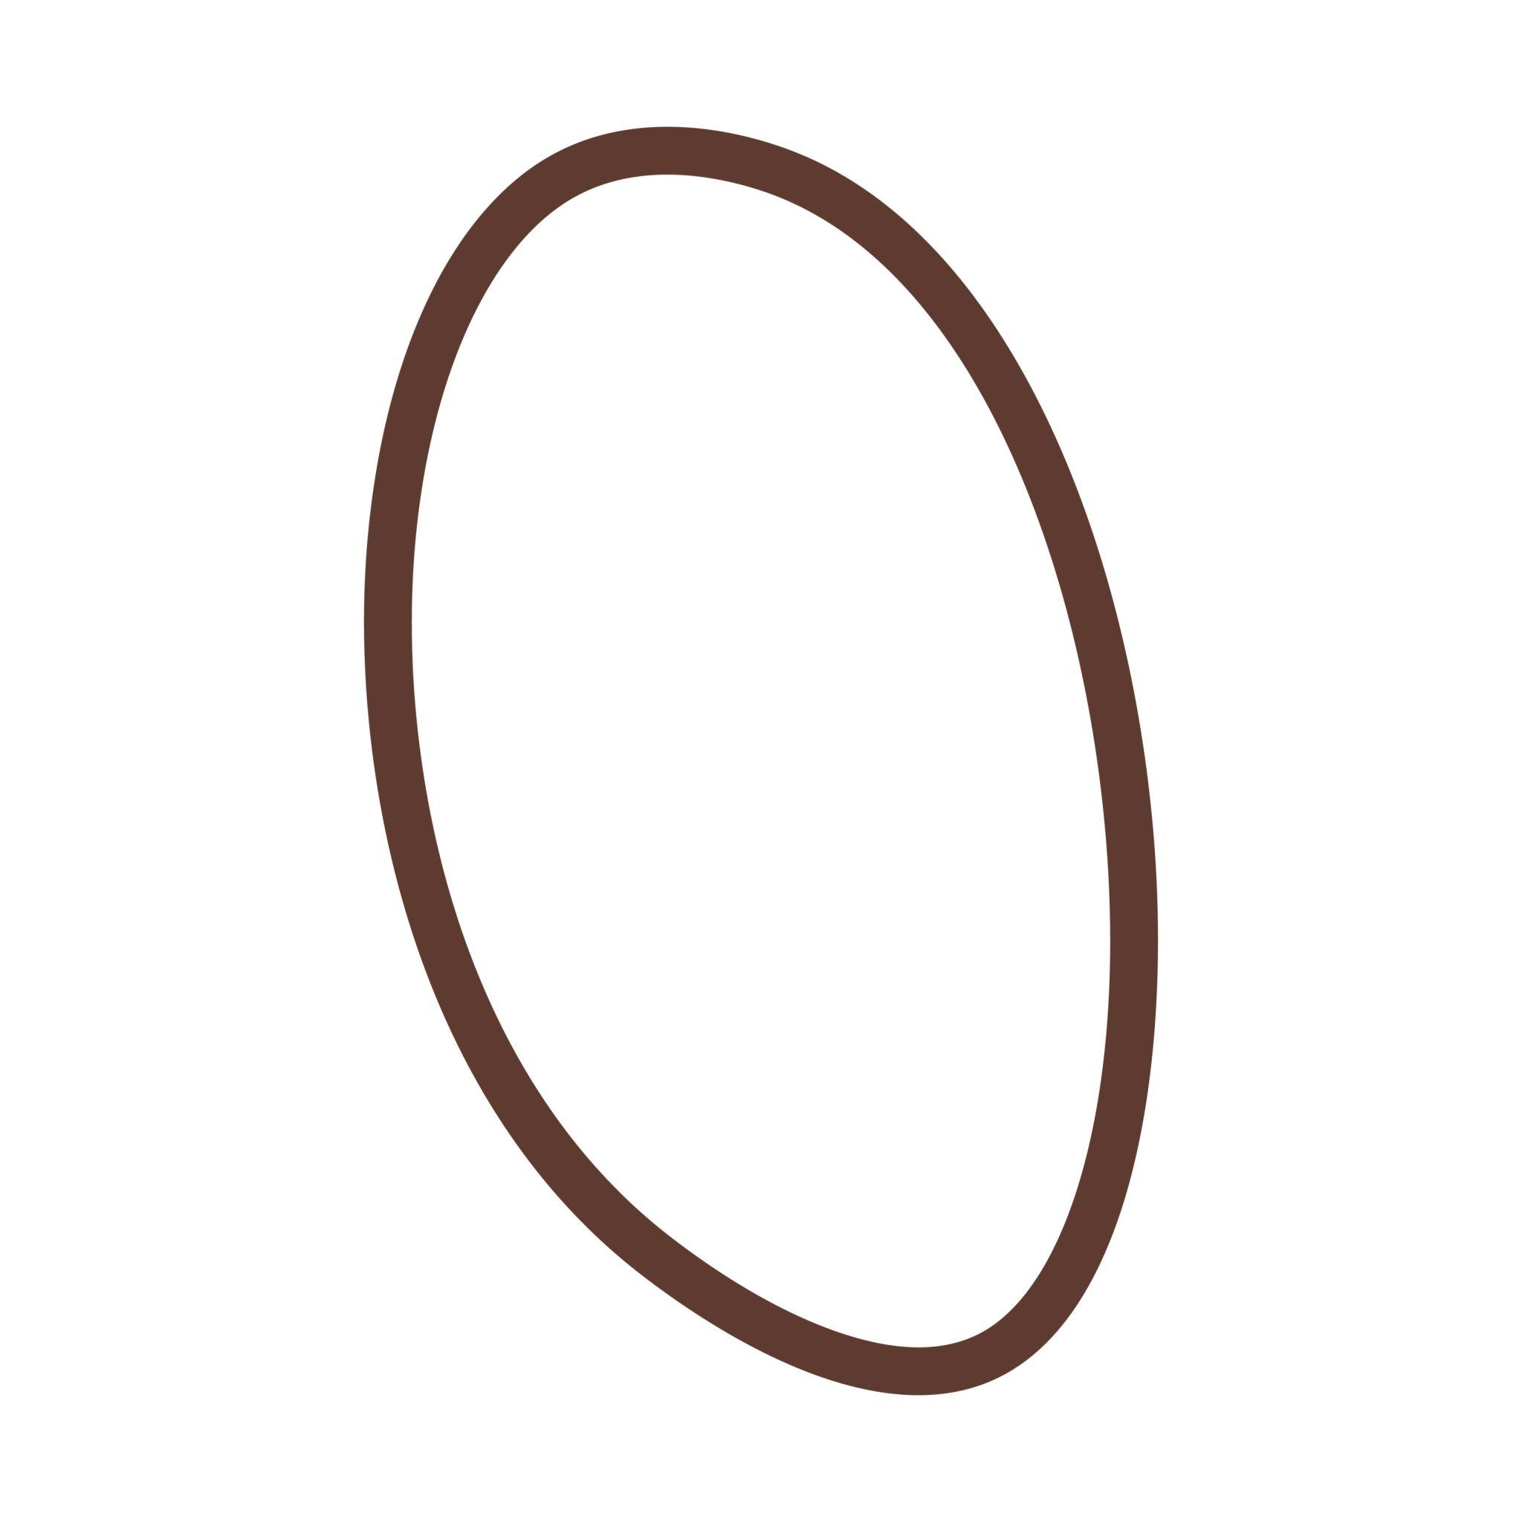
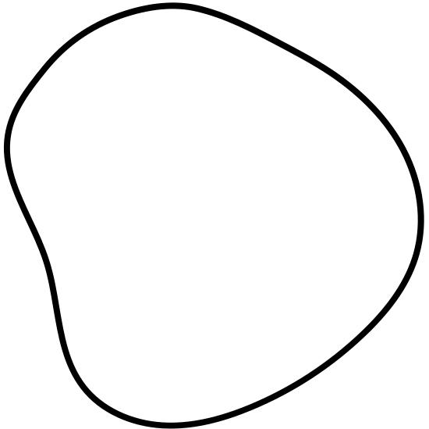
For example, one end may be more pointed or narrower than the other.
This includes many egg-like forms.

2. Egg-Shaped Asymmetric Curves
# Source: AI Source: Provided by: [Data Path: Persons Table -> ID Column: 1, Name_En Column: Motasem Essam] -> From: [ChatGPT] on [7/25/2026]
An egg-shaped curve is wider toward one end and narrower toward the other.
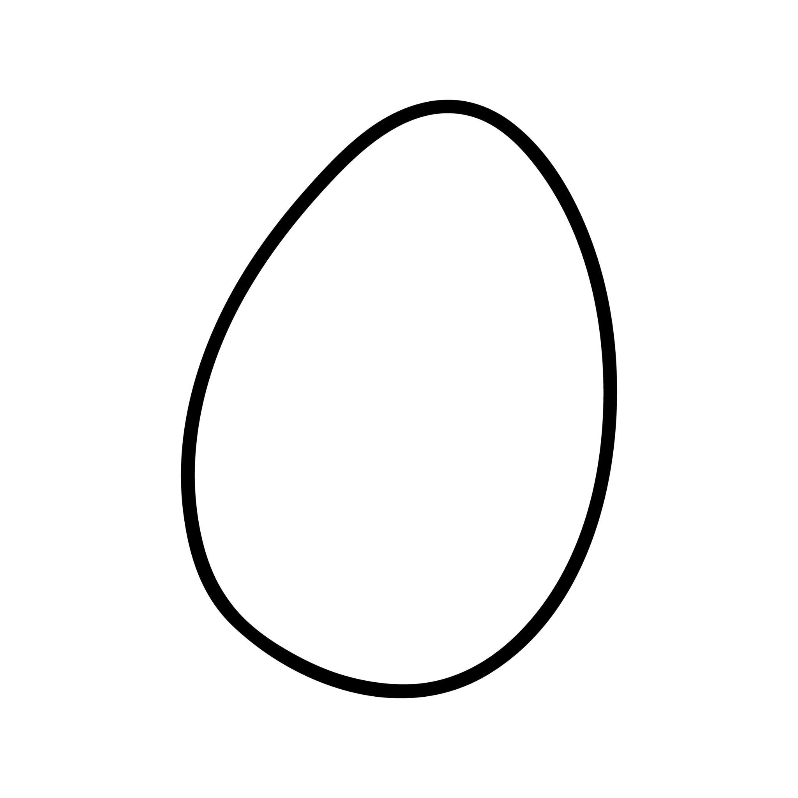
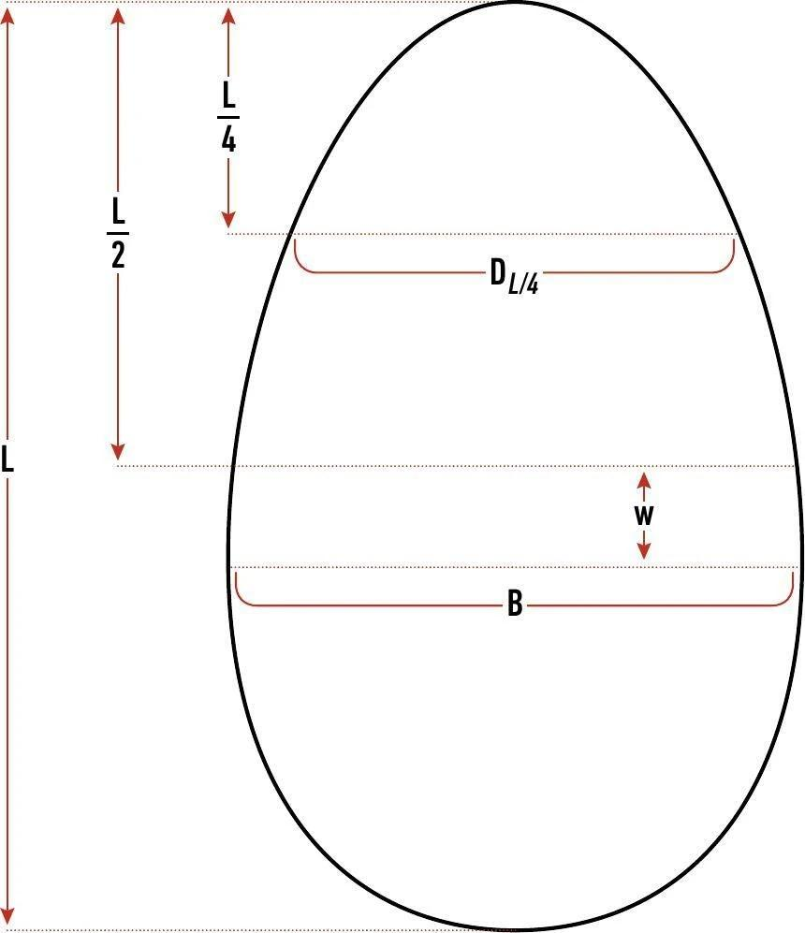
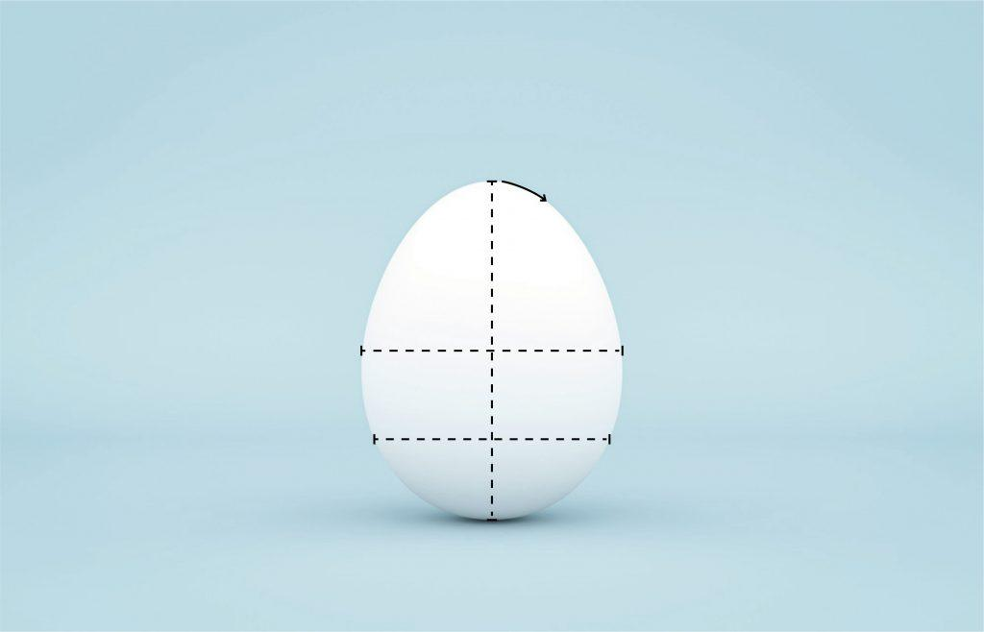
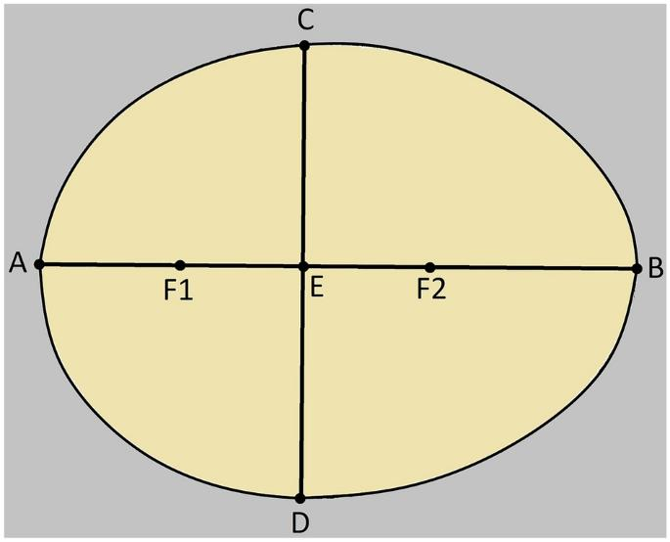
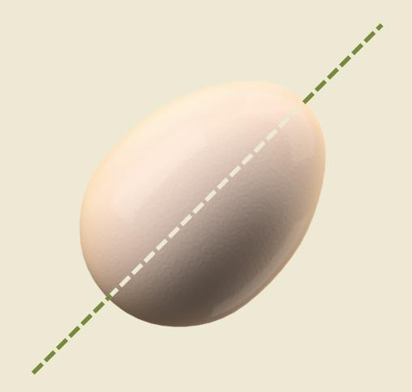
It is closed and smooth but generally lacks horizontal reflection symmetry.
$$\boxed{\text{Egg Shape}→\text{Asymmetric Oval}}$$

3. Asymmetric Organic Closed Curves
# Source: AI Source: Provided by: [Data Path: Persons Table -> ID Column: 1, Name_En Column: Motasem Essam] -> From: [ChatGPT] on [7/25/2026]
These are natural-looking closed curves with uneven curvature.
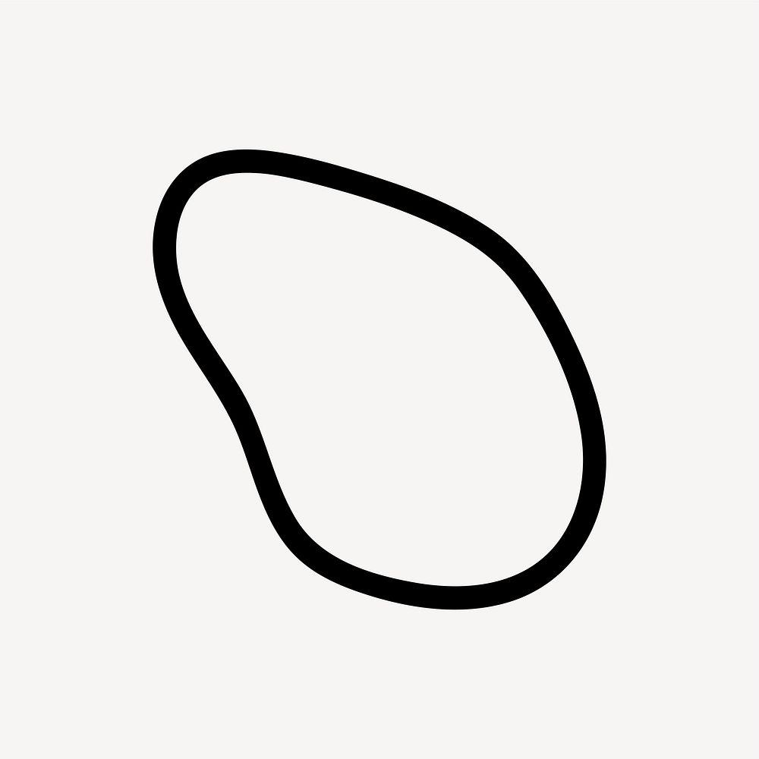
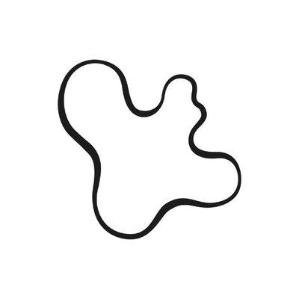
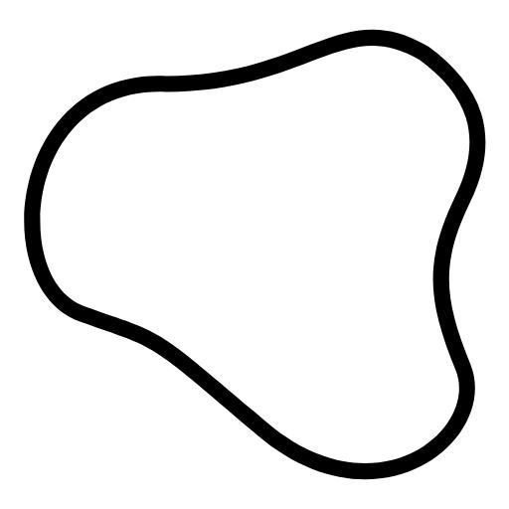
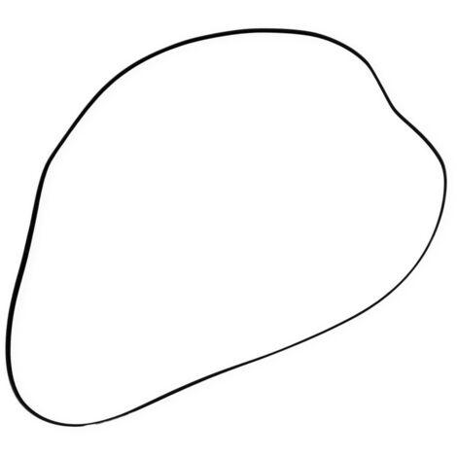
Examples can resemble:
- Leaves.
- Stones.
- Seeds.
- Biological cells.
- Natural objects.

4. Asymmetric Wavy Closed Curves
# Source: AI Source: Provided by: [Data Path: Persons Table -> ID Column: 1, Name_En Column: Motasem Essam] -> From: [ChatGPT] on [7/25/2026]
These shapes have wave-like undulations that are not evenly distributed.
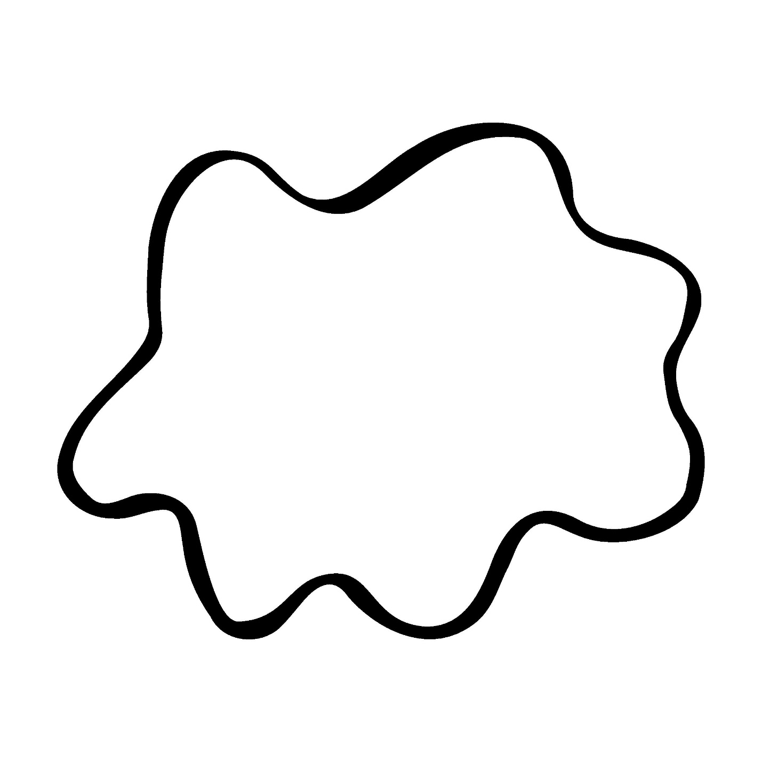
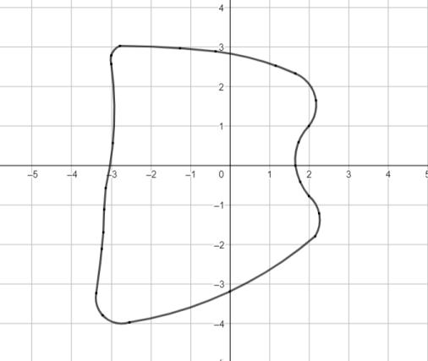
For example:
- Large bulges on one side.
- Small waves on the other.
- Unequal wave spacing.
- Different curvature along the boundary.

5. Asymmetric Lobed Closed Curves
# Source: AI Source: Provided by: [Data Path: Persons Table -> ID Column: 1, Name_En Column: Motasem Essam] -> From: [ChatGPT] on [7/25/2026]
A lobed closed curve has rounded protrusions, but an asymmetric version has unequal lobes.
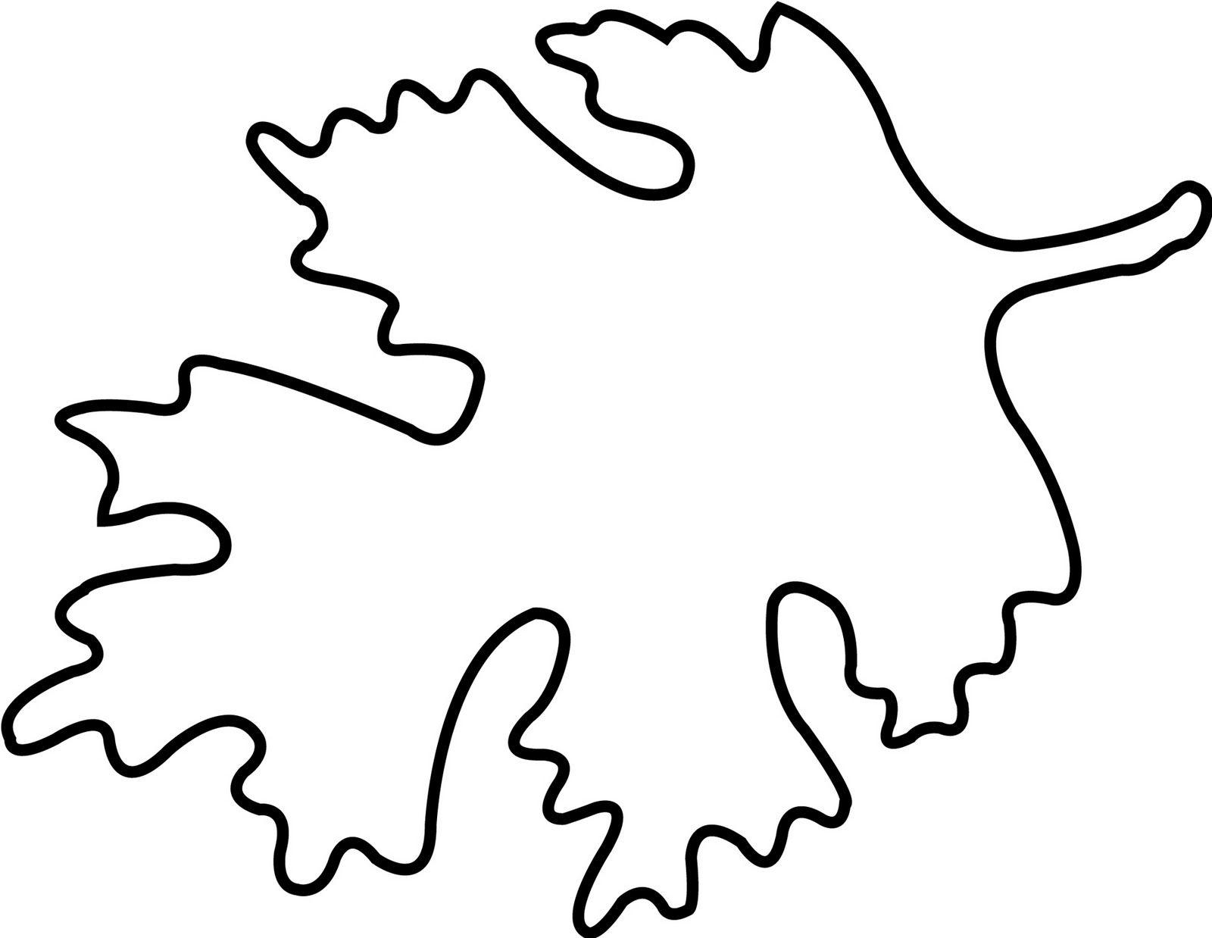
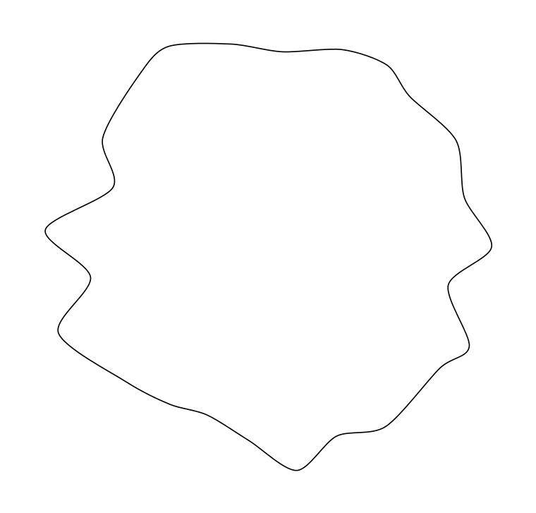
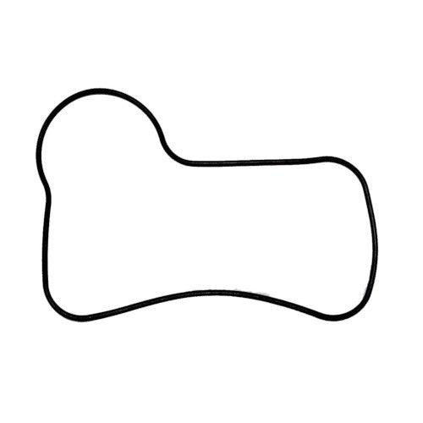
The lobes may differ in:
- Size.
- Shape.
- Spacing.
- Curvature.

6. Asymmetric Freeform Closed Curves
# Source: AI Source: Provided by: [Data Path: Persons Table -> ID Column: 1, Name_En Column: Motasem Essam] -> From: [ChatGPT] on [7/25/2026]
These are artificially designed closed curves with freely controlled and unequal curvature.
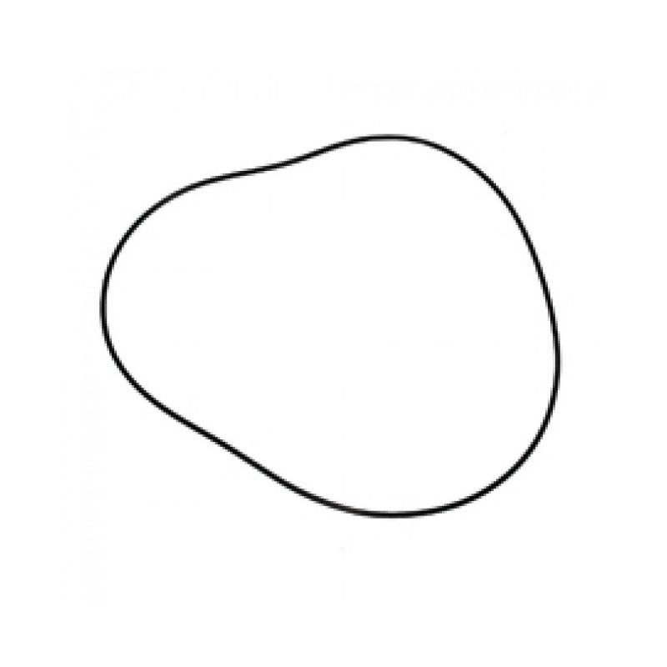
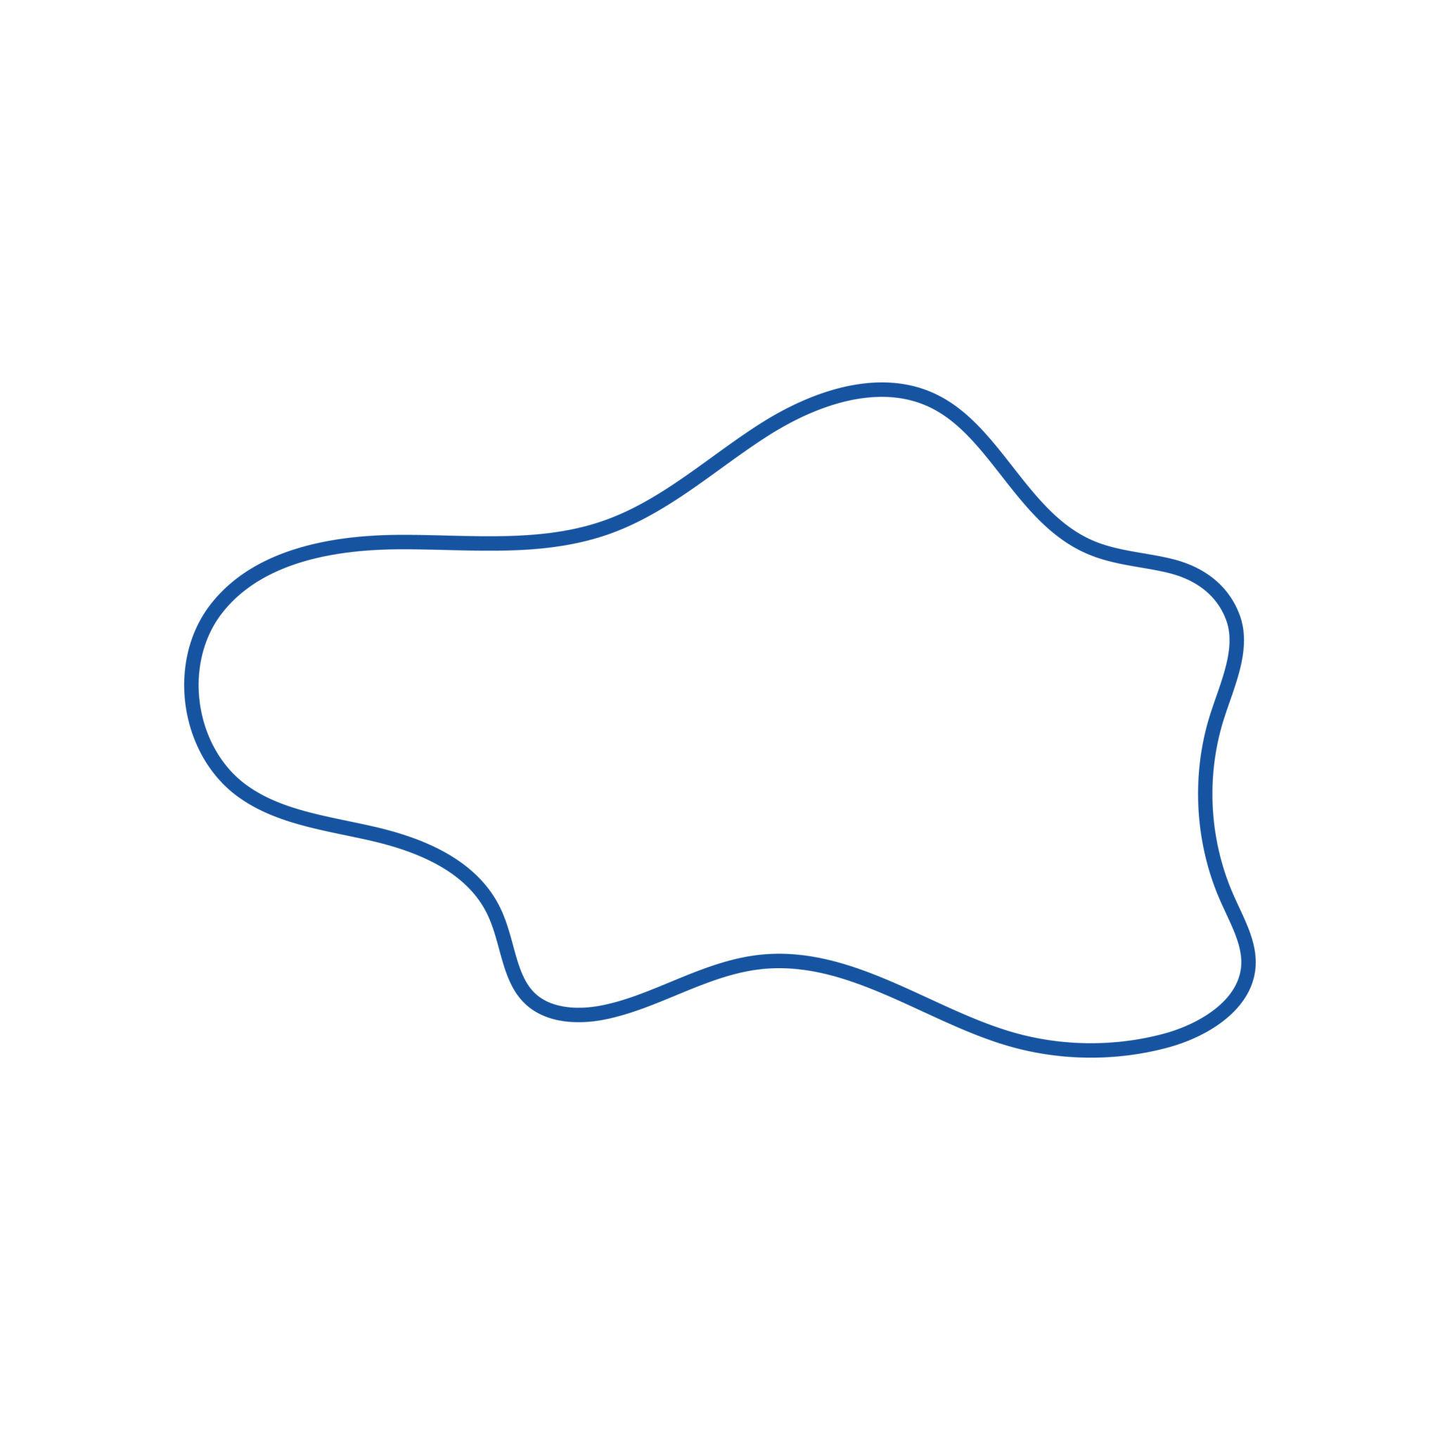
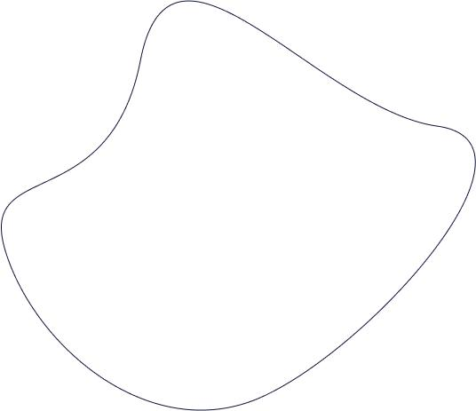
They are common in:
- Graphic design.
- CAD.
- Product design.
- Illustration.
- Computer graphics.

7. Asymmetric Bézier Closed Curves
# Source: AI Source: Provided by: [Data Path: Persons Table -> ID Column: 1, Name_En Column: Motasem Essam] -> From: [ChatGPT] on [7/25/2026]
A closed Bézier path can be deliberately constructed without symmetry.
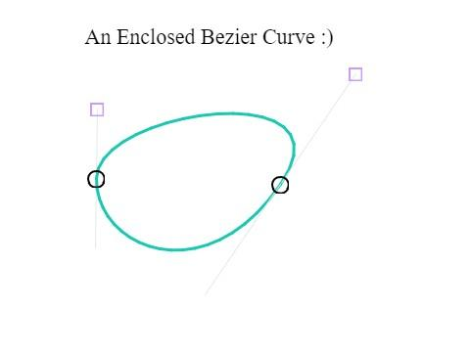
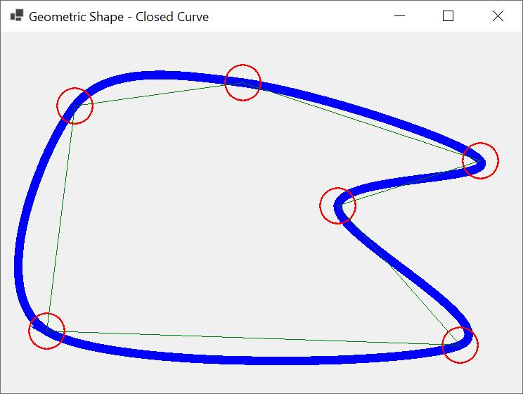
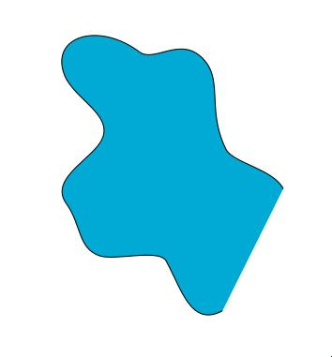
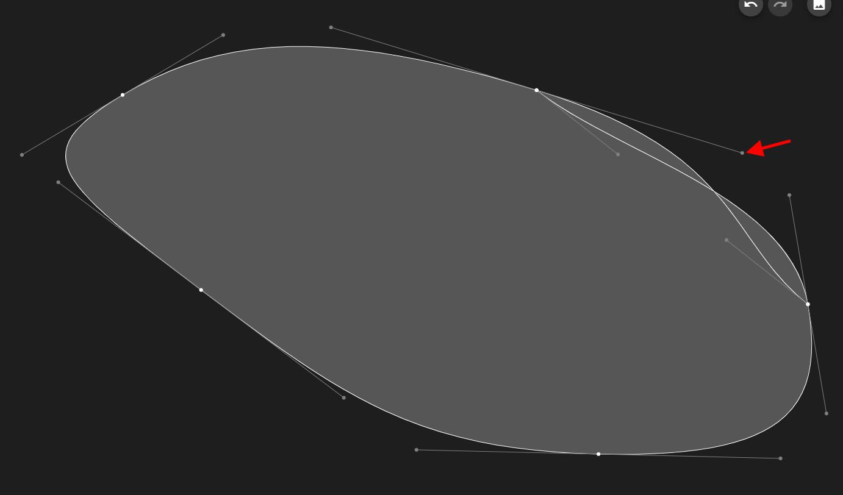
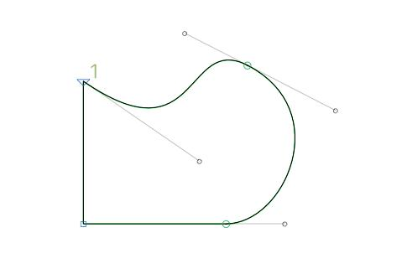
The control points can be positioned differently around the curve, producing an asymmetric boundary.

8. Asymmetric Spline Closed Curves
# Source: AI Source: Provided by: [Data Path: Persons Table -> ID Column: 1, Name_En Column: Motasem Essam] -> From: [ChatGPT] on [7/25/2026]
Spline-based curves can also produce asymmetric closed shapes.
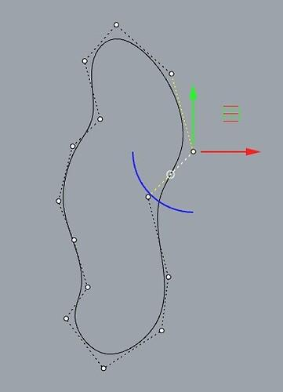
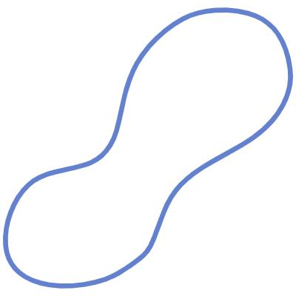
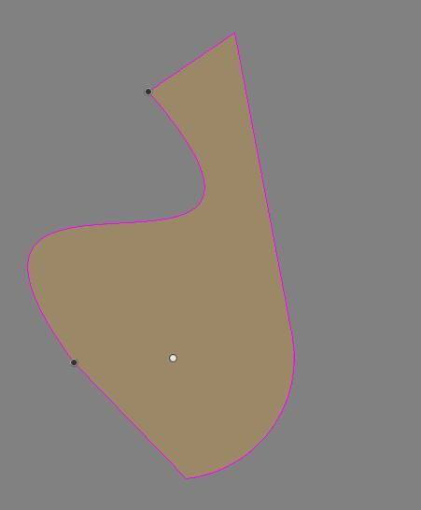
Changing the position of individual control points changes local curvature without necessarily affecting the rest of the shape.

9. Asymmetric Droplet Closed Curves
# Source: AI Source: Provided by: [Data Path: Persons Table -> ID Column: 1, Name_En Column: Motasem Essam] -> From: [ChatGPT] on [7/25/2026]
These resemble drops but have an uneven or off-center form.
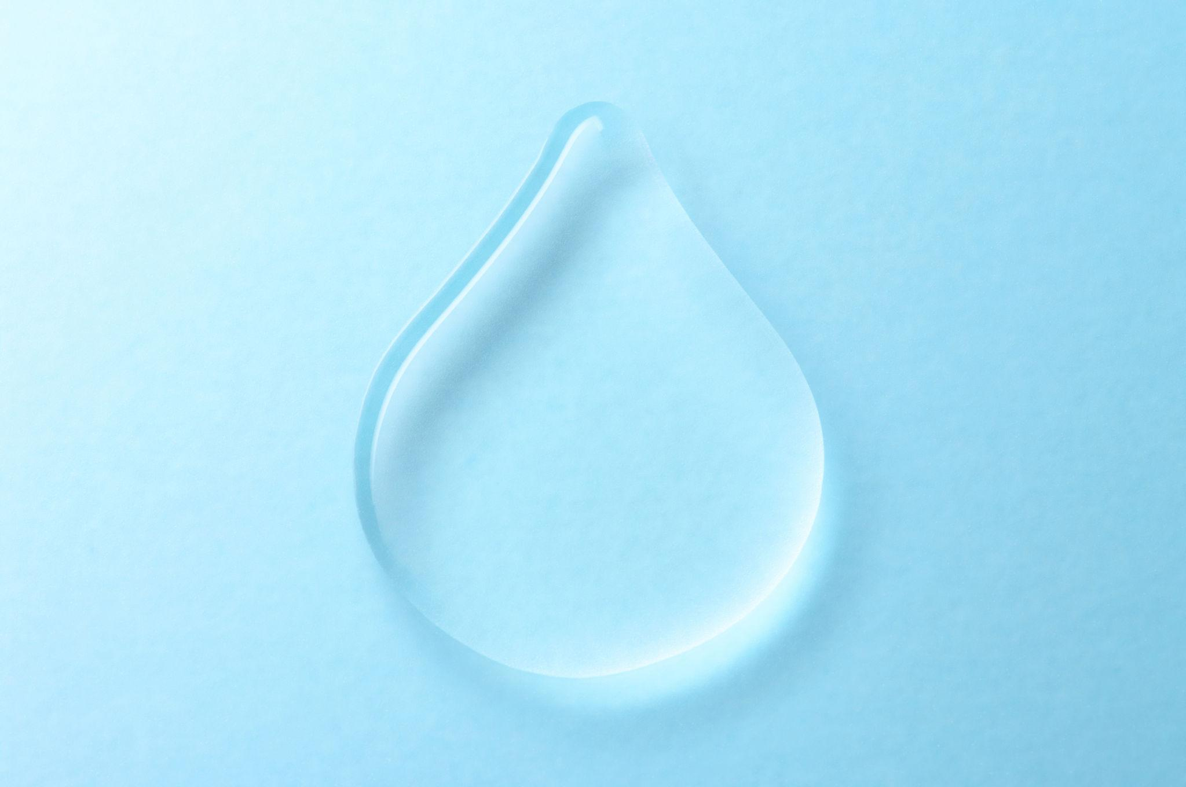
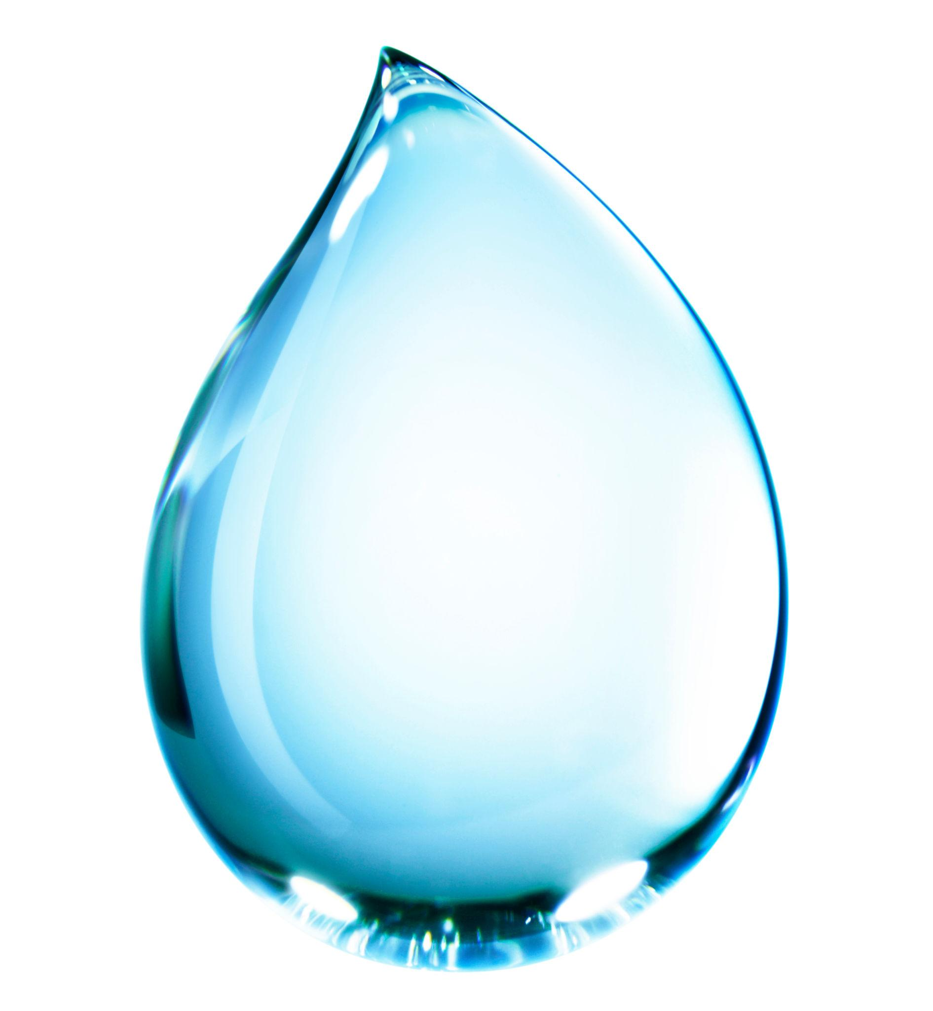
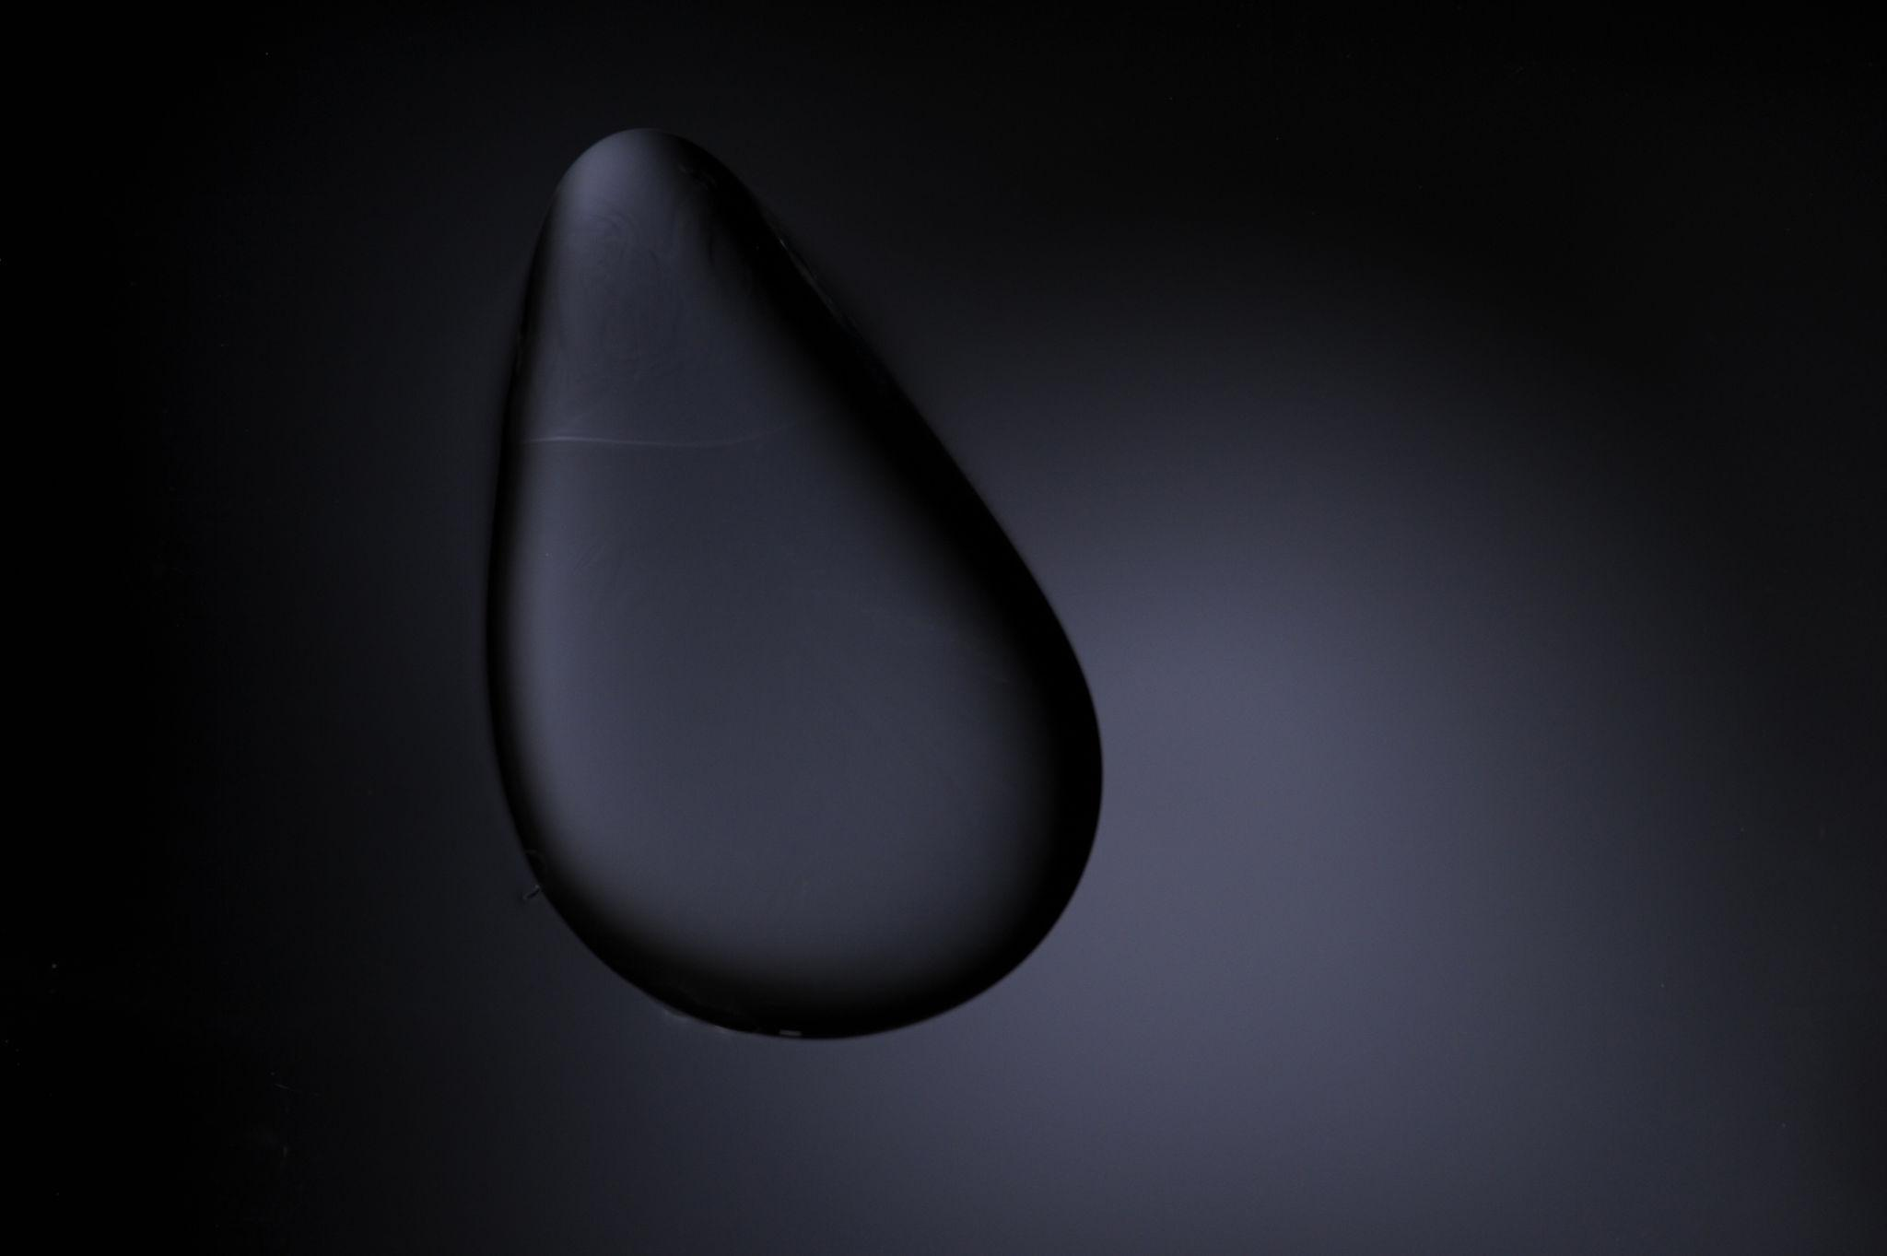
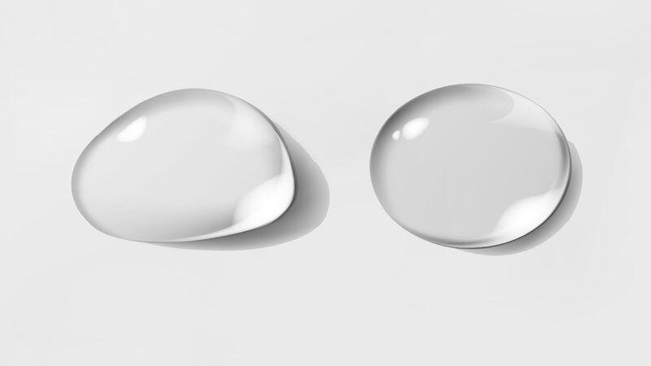
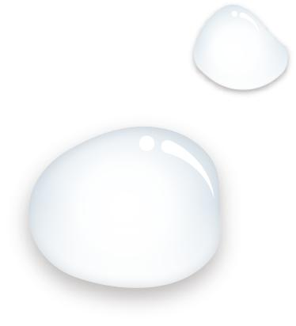
One side may be steeper while the other is more rounded.

10. Asymmetric Natural Closed Curves
# Source: AI Source: Provided by: [Data Path: Persons Table -> ID Column: 1, Name_En Column: Motasem Essam] -> From: [ChatGPT] on [7/25/2026]
These are closed curved boundaries that occur naturally and lack regular symmetry.
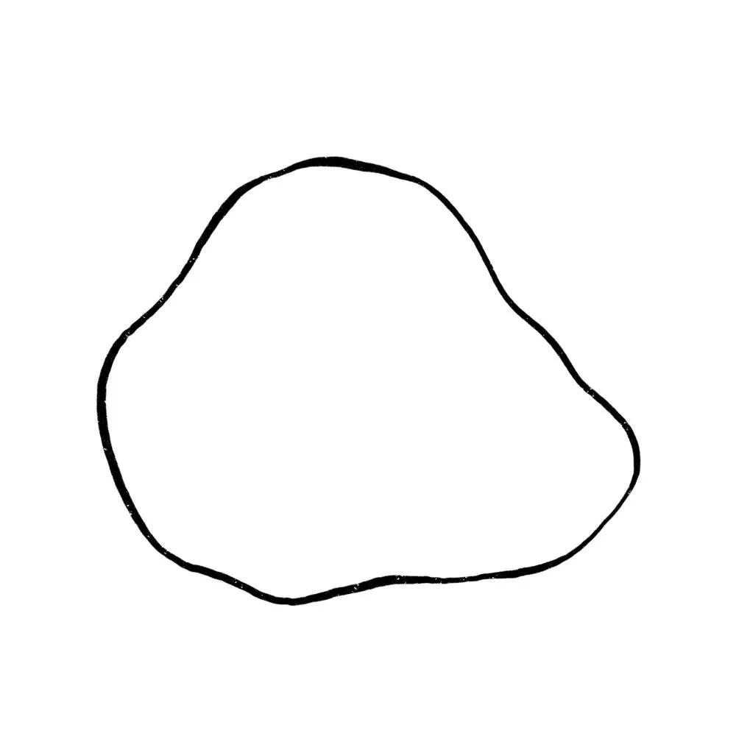
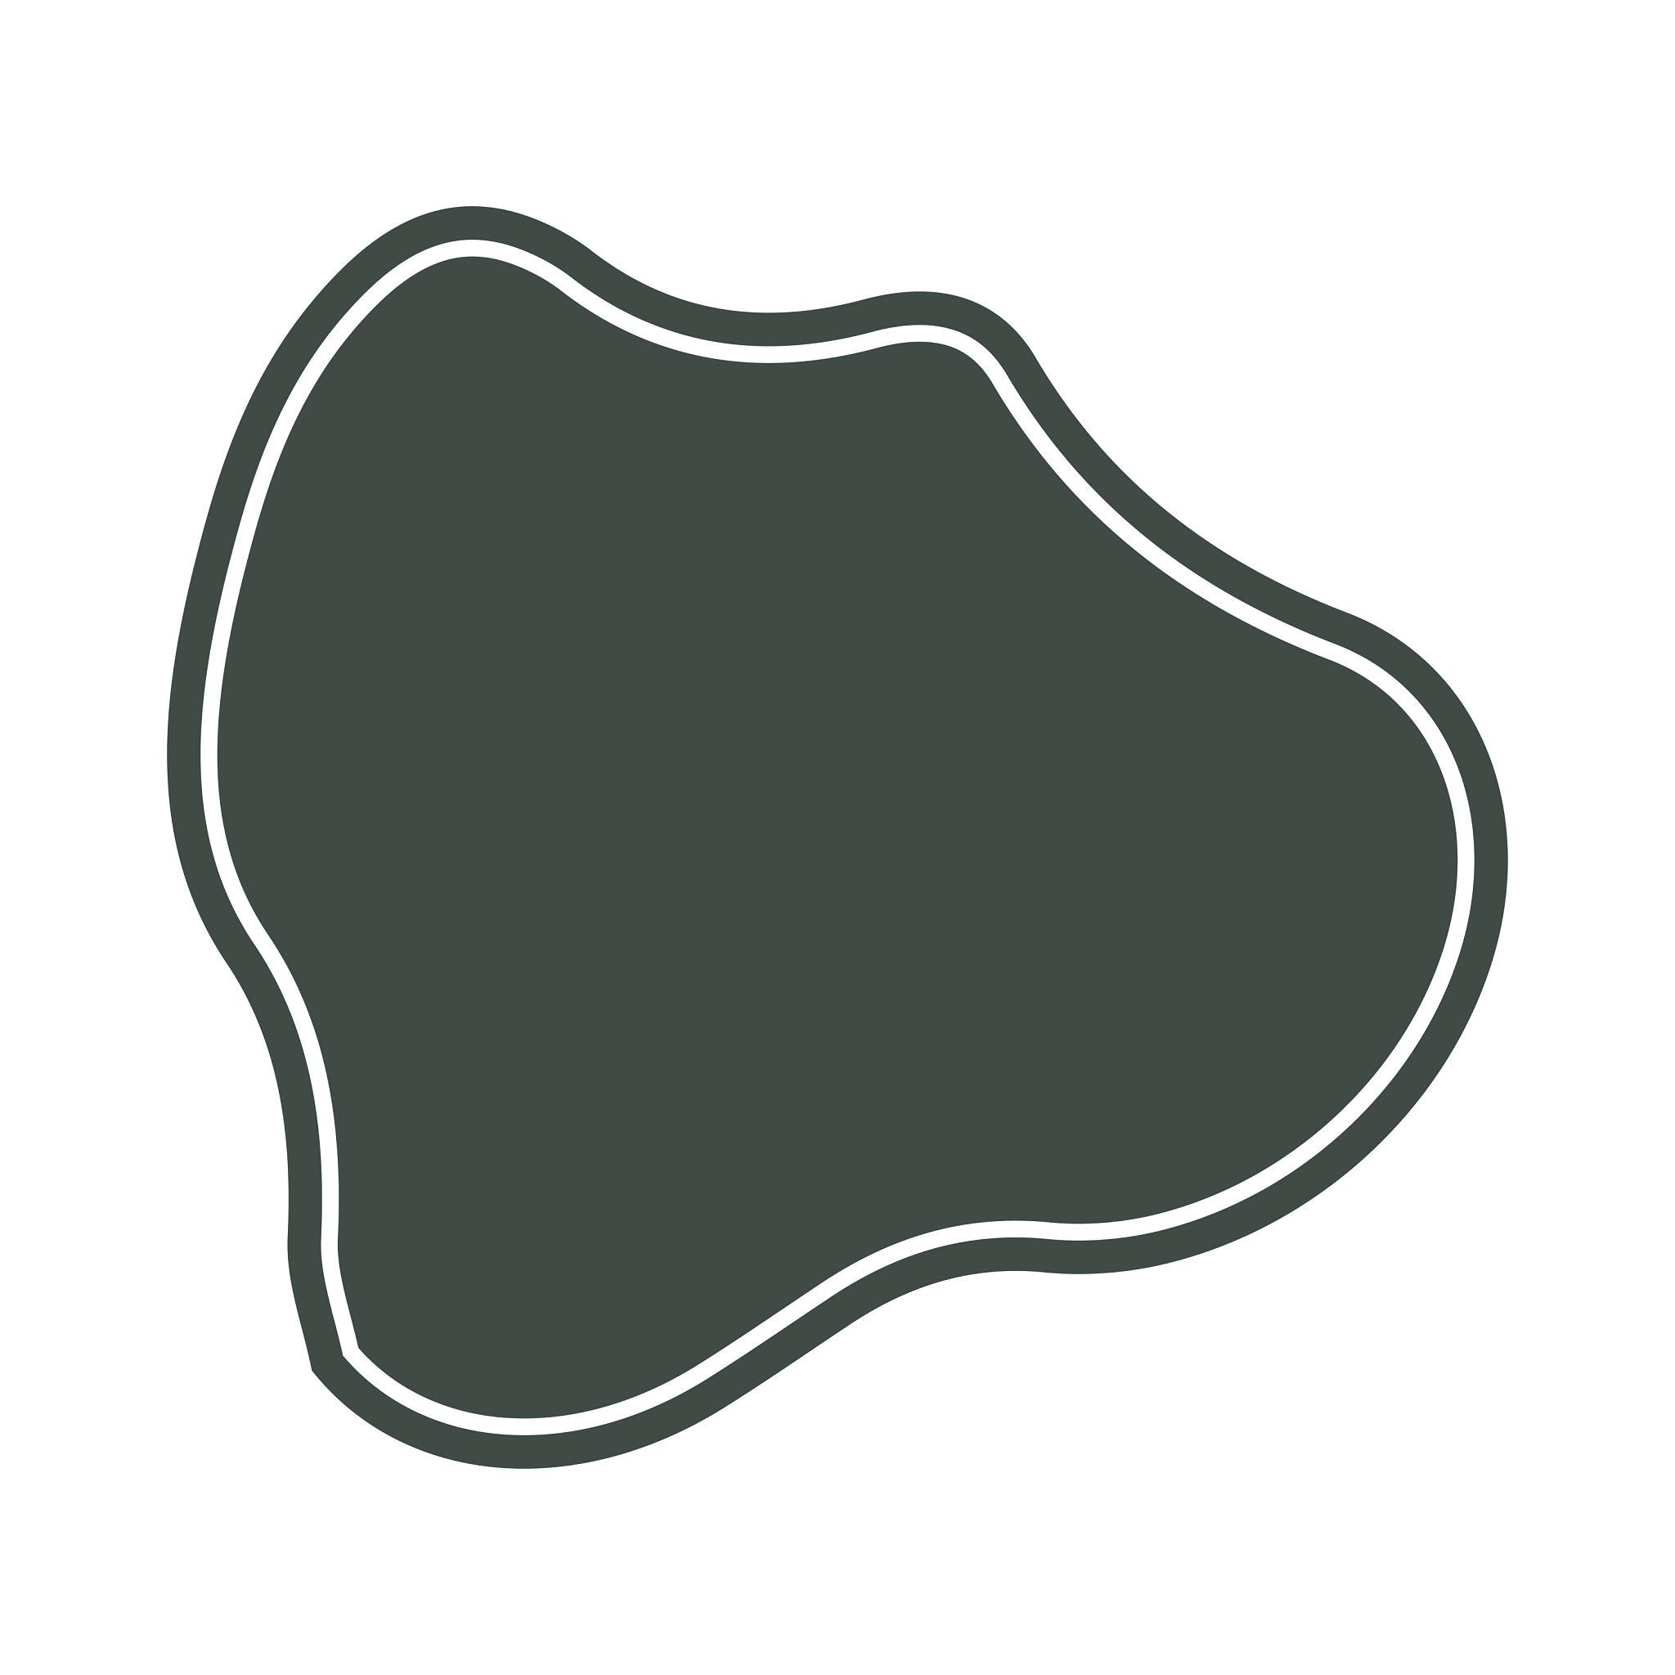
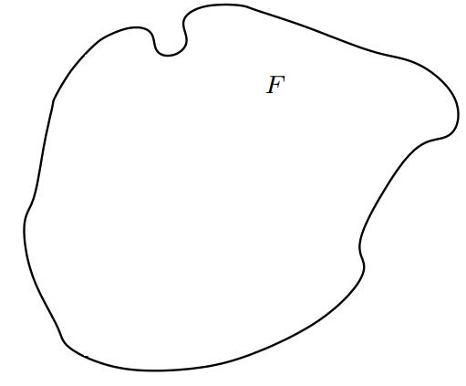
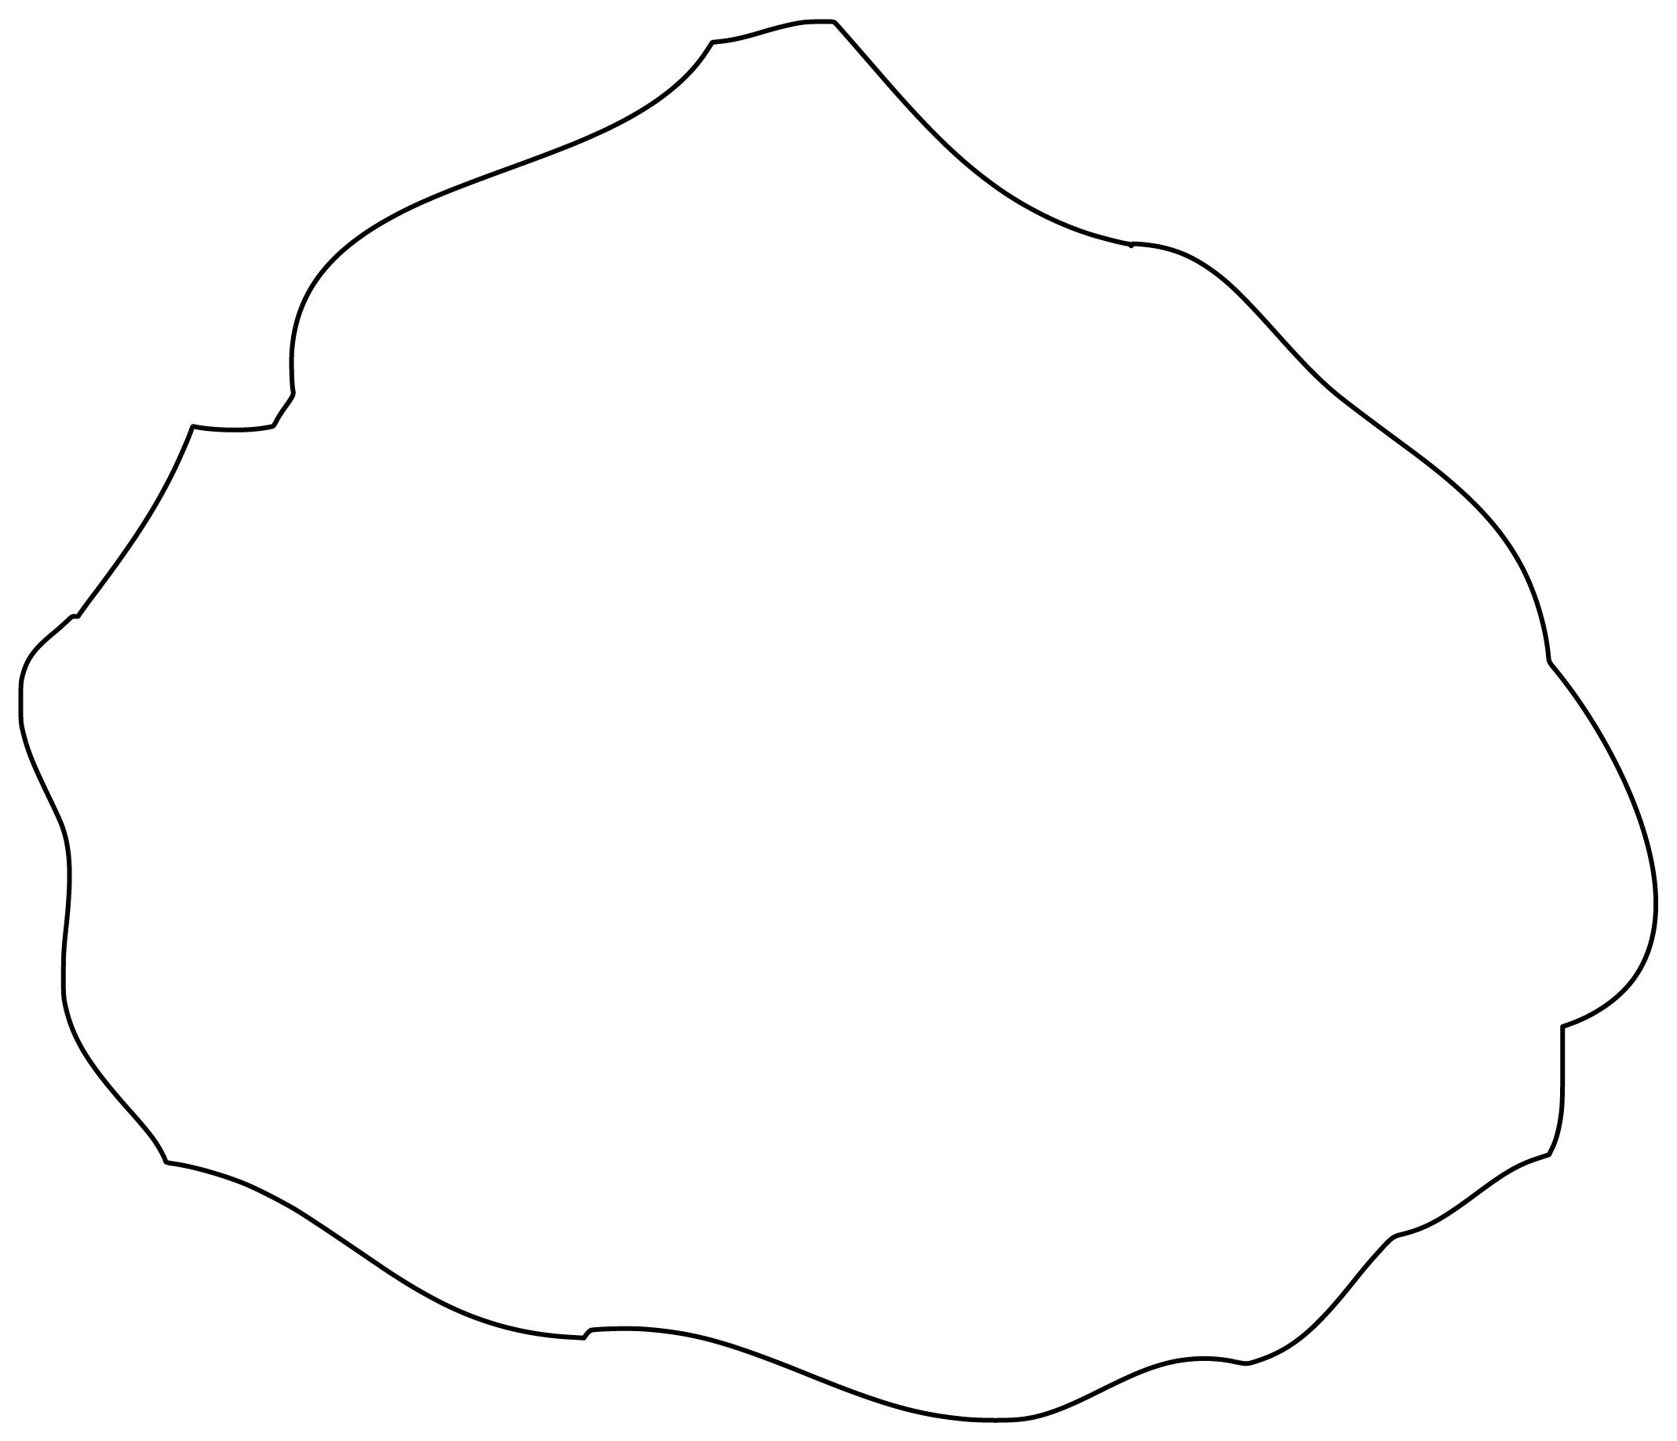
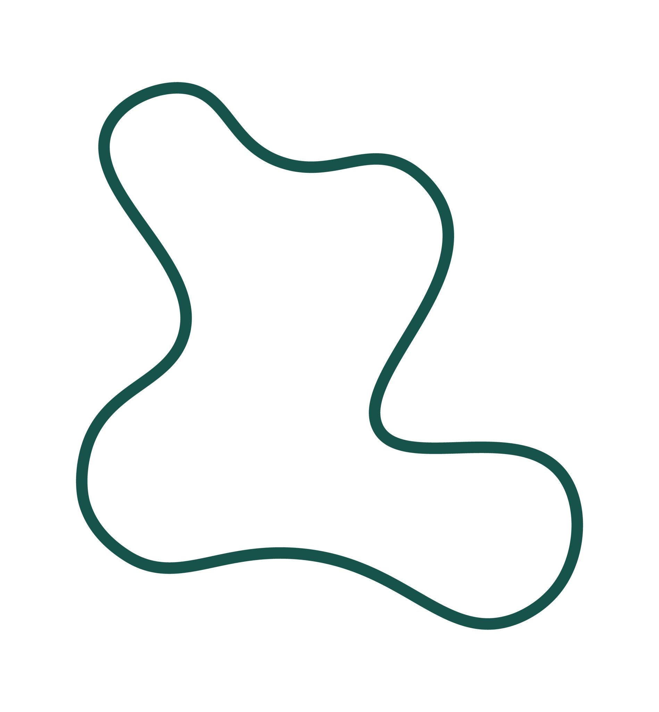
Examples include irregular boundaries of:
- Rocks.
- Puddles.
- Biological forms.
- Natural objects.

Asymmetric vs. Symmetric Closed Curved Shapes
# Source: AI Source: Provided by: [Data Path: Persons Table -> ID Column: 1, Name_En Column: Motasem Essam] -> From: [ChatGPT] on [7/25/2026]
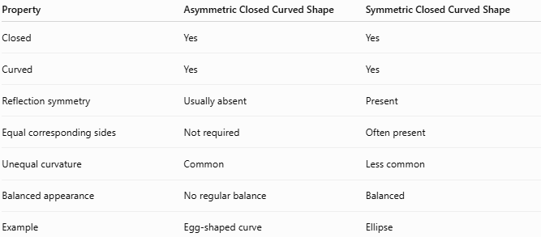
Property | Asymmetric Closed Curved Shape | Symmetric Closed Curved Shape
Closed | Yes | Yes
Curved | Yes | Yes
Reflection symmetry | Usually absent | Present
Equal corresponding sides | Not required | Often present
Unequal curvature | Common | Less common
Balanced appearance | No regular balance | Balanced
Example | Egg-shaped curve | Ellipse
The fundamental distinction is:
$$\boxed{\text{Symmetric}⇒\text{Matching geometric structure}}$$
whereas:
$$\boxed{\text{Asymmetric}⇒\text{No regular matching structure}}$$

Asymmetric vs. Organic Closed Curved Shapes
# Source: AI Source: Provided by: [Data Path: Persons Table -> ID Column: 1, Name_En Column: Motasem Essam] -> From: [ChatGPT] on [7/25/2026]
These categories can overlap.
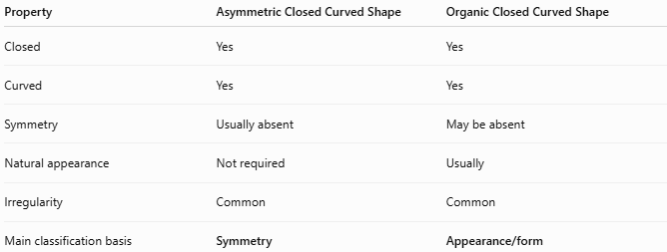
Property | Asymmetric Closed Curved Shape | Organic Closed Curved Shape
Closed | Yes | Yes
Curved | Yes | Yes
Symmetry | Usually absent | May be absent
Natural appearance | Not required | Usually
Irregularity | Common | Common
Main classification basis | Symmetry | Appearance/form
Therefore, an asymmetric leaf-like shape can be classified simultaneously as:
$$\boxed{\text{Asymmetric}+\text{Organic}+\text{Closed}+\text{Curved}}$$

Asymmetric vs. Freeform Closed Curved Shapes
# Source: AI Source: Provided by: [Data Path: Persons Table -> ID Column: 1, Name_En Column: Motasem Essam] -> From: [ChatGPT] on [7/25/2026]
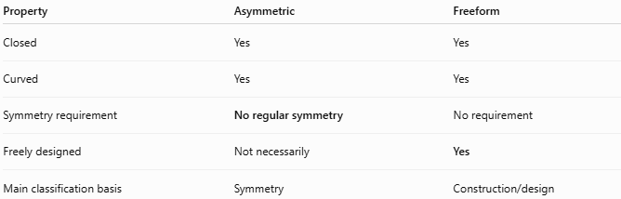
Property | Asymmetric | Freeform
Closed | Yes | Yes
Curved | Yes | Yes
Symmetry requirement | No regular symmetry | No requirement
Freely designed | Not necessarily | Yes
Main classification basis | Symmetry | Construction/design
A freeform curve can actually be symmetric.
Therefore:
$$\boxed{\text{Freeform}⇏\text{Asymmetric}}$$
but a particular freeform curve may be both.

Asymmetric vs. Wavy Closed Curved Shapes
# Source: AI Source: Provided by: [Data Path: Persons Table -> ID Column: 1, Name_En Column: Motasem Essam] -> From: [ChatGPT] on [7/25/2026]
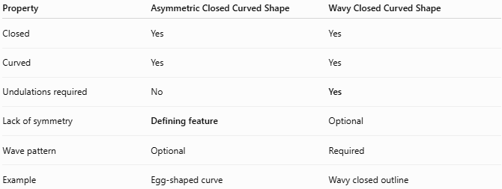
Property | Asymmetric Closed Curved Shape | Wavy Closed Curved Shape
Closed | Yes | Yes
Curved | Yes | Yes
Undulations required | No | Yes
Lack of symmetry | Defining feature | Optional
Wave pattern | Optional | Required
Example | Egg-shaped curve | Wavy closed outline
Thus, a shape can belong to both categories:
$$\boxed{\text{Asymmetric Wavy Closed Curve}}$$
if it has both asymmetry and irregular waves.

Symmetry
# Source: AI Source: Provided by: [Data Path: Persons Table -> ID Column: 1, Name_En Column: Motasem Essam] -> From: [ChatGPT] on [7/25/2026]
The simplest test for asymmetry is reflection.
If reflecting the shape across a proposed axis does not reproduce the same shape, then that axis is not a symmetry axis.
$$\boxed{R_{\text{axis}}\left(S\right)≠S}$$
for the proposed reflection (R_{\text{axis}}).
An asymmetric shape generally has:
$$\boxed{\text{No line of reflection symmetry}}$$
However, absence of reflection symmetry does not automatically mean absence of every possible symmetry. Some shapes may possess rotational symmetry.

Area
# Source: AI Source: Provided by: [Data Path: Persons Table -> ID Column: 1, Name_En Column: Motasem Essam] -> From: [ChatGPT] on [7/25/2026]
Because an asymmetric closed curve encloses a region, its area can be defined.
For a general curve there is no universal simple formula.
For a parametric closed curve:
$$x=x\left(t\right), y=y\left(t\right)$$
the area can be calculated using:
$$\boxed{A=\frac{1}{2}\oint{\left(x,dy-y dx\right)}}$$

Boundary Length
# Source: AI Source: Provided by: [Data Path: Persons Table -> ID Column: 1, Name_En Column: Motasem Essam] -> From: [ChatGPT] on [7/25/2026]
The boundary length is the arc length of the closed curve.
For a parametric curve:
$$\boxed{L=\int_{a}^{b}{\sqrt{{\left(\frac{dx}{dt}\right)}^{2}+{\left(\frac{dy}{dt}\right)}^{2}}}dt}$$
where:
$$\left(x\left(a\right),y\left(a\right)\right)=\left(x\left(b\right),y\left(b\right)\right).$$

Key Points
# Source: AI Source: Provided by: [Data Path: Persons Table -> ID Column: 1, Name_En Column: Motasem Essam] -> From: [ChatGPT] on [7/25/2026]
An Asymmetric Closed Curved Shape is:
$$\boxed{\text{Closed}+\text{Curved}+\text{No Regular Symmetry}}$$
It:
- Has a continuous closed boundary.
- Encloses a bounded region.
- Has no open endpoints.
- Usually has no line of reflection symmetry.
- Can have unequal curvature, bulges, or widths.
- Can be organic, oval-like, wavy, lobed, or freeform.
- Can be naturally occurring or artificially designed.

Conclusion
# Source: AI Source: Provided by: [Data Path: Persons Table -> ID Column: 1, Name_En Column: Motasem Essam] -> From: [ChatGPT] on [7/25/2026]
Asymmetric Closed Curved Shapes are closed curved forms distinguished primarily by their lack of regular symmetry. They include asymmetric ovals, egg-shaped curves, organic curves, wavy curves, lobed curves, freeform curves, Bézier curves, spline curves, droplet-like curves, and natural irregular curves. Because asymmetry describes symmetry rather than construction or appearance, an individual shape may belong to several classifications simultaneously—for example, an asymmetric organic wavy closed curve.

